**DAY-4**

Q.No.14 Write a high level code for PT-109 American patrol boat, under the command of Lieutenant Jodhn F.

Kennedy, was sunk by a Japanese destroyer, a message was received at an Australian wireless station in

Playfair code:

KXJEY UREBE ZWEHE WRYTU HEYFS

KREHE GOYFI WTTTU OLKSY CAJPO

BOTEI ZONTX BYBNT GONEY CUZWR

GDSON SXBOU YWRHE BAAHY USEDQ

**PROGRAM:**

public class PlayfairCipherDecoder {

public static void main(String[] args) {

String ciphertext = "KXJEY UREBE ZWEHE WRYTU HEYFS\n" +

"KREHE GOYFI WTTTU OLKSY CAJPO\n" +

"BOTEI ZONTX BYBNT GONEY CUZWR\n" +

"GDSON SXBOU YWRHE BAAHY USEDQ";

// Remove all whitespace and convert to uppercase

String plaintext = ciphertext.replaceAll("\\s+", "").toUpperCase();

// Generate the Playfair matrix

char[][] matrix = generateMatrix("JOHNFKENNEDY");

// Decode the ciphertext using the Playfair algorithm

StringBuilder sb = new StringBuilder();

for (int i = 0; i < plaintext.length(); i += 2) {

char c1 = plaintext.charAt(i);

char c2 = plaintext.charAt(i + 1);

int[] pos1 = findPosition(matrix, c1);

int[] pos2 = findPosition(matrix, c2);

if (pos1[0] == pos2[0]) { // same row

sb.append(matrix[pos1[0]][(pos1[1] + 4) % 5]);

sb.append(matrix[pos2[0]][(pos2[1] + 4) % 5]);

} else if (pos1[1] == pos2[1]) { // same column

sb.append(matrix[(pos1[0] + 4) % 5][pos1[1]]);

sb.append(matrix[(pos2[0] + 4) % 5][pos2[1]]);

} else { // different row and column

sb.append(matrix[pos1[0]][pos2[1]]);

sb.append(matrix[pos2[0]][pos1[1]]);

}

}

// Print the decoded message

System.out.println(sb.toString());

}

// Generate the Playfair matrix from the keyword

public static char[][] generateMatrix(String keyword) {

String key = keyword.toUpperCase().replaceAll("[^A-Z]", "");

key = key + "ABCDEFGHIKLMNOPQRSTUVWXYZ";

char[] keyArray = key.toCharArray();

char[][] matrix = new char[5][5];

int index = 0;

for (int i = 0; i < 5; i++) {

for (int j = 0; j < 5; j++) {

matrix[i][j] = keyArray[index];

index++;

}

}

return matrix;

}

// Find the position of a character in the Playfair matrix

public static int[] findPosition(char[][] matrix, char c) {

int[] pos = new int[2];

for (int i = 0; i < 5; i++) {

for (int j = 0; j < 5; j++) {

if (matrix[i][j] == c) {

pos[0] = i;

pos[1] = j;

break;

}

}

}

return pos;

}

}

**OUTPUT:**

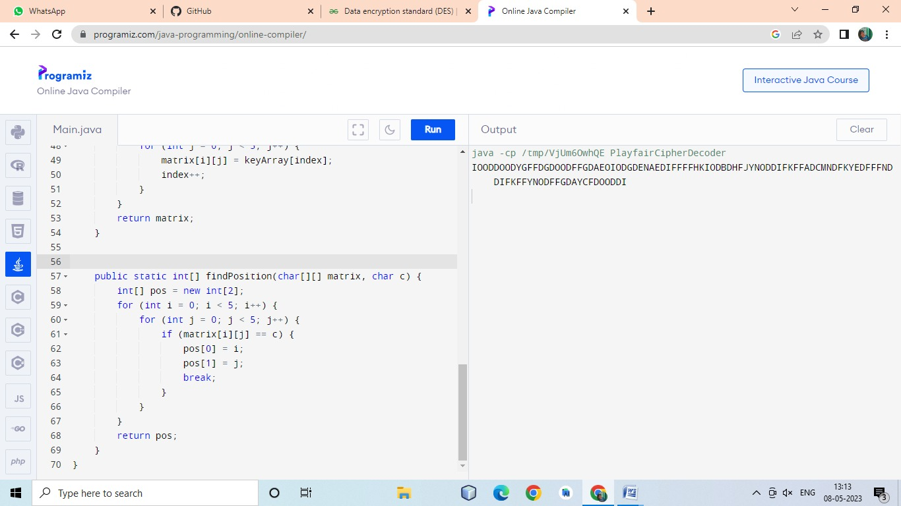

Q.No.15. Write a high level program for DES the first 24 bits of each 1subkey come from the same subset of 28 bits of the initial key and the second 24 bits of each subkey come from a disjoint subset of 28 bits of the initial key.

**PROGRAM:**

# Python3 code for the above approach

# Hexadecimal to binary conversion

def hex2bin(s):

mp = {'0': "0000",

'1': "0001",

'2': "0010",

'3': "0011",

'4': "0100",

'5': "0101",

'6': "0110",

'7': "0111",

'8': "1000",

'9': "1001",

'A': "1010",

'B': "1011",

'C': "1100",

'D': "1101",

'E': "1110",

'F': "1111"}

bin = ""

for i in range(len(s)):

bin = bin + mp[s[i]]

return bin

# Binary to hexadecimal conversion

def bin2hex(s):

mp = {"0000": '0',

"0001": '1',

"0010": '2',

"0011": '3',

"0100": '4',

"0101": '5',

"0110": '6',

"0111": '7',

"1000": '8',

"1001": '9',

"1010": 'A',

"1011": 'B',

"1100": 'C',

"1101": 'D',

"1110": 'E',

"1111": 'F'}

hex = ""

for i in range(0, len(s), 4):

ch = ""

ch = ch + s[i]

ch = ch + s[i + 1]

ch = ch + s[i + 2]

ch = ch + s[i + 3]

hex = hex + mp[ch]

return hex

# Binary to decimal conversion

def bin2dec(binary):

binary1 = binary

decimal, i, n = 0, 0, 0

while(binary != 0):

dec = binary % 10

decimal = decimal + dec * pow(2, i)

binary = binary//10

i += 1

return decimal

# Decimal to binary conversion

def dec2bin(num):

res = bin(num).replace("0b", "")

if(len(res) % 4 != 0):

div = len(res) / 4

div = int(div)

counter = (4 * (div + 1)) - len(res)

for i in range(0, counter):

res = '0' + res

return res

# Permute function to rearrange the bits

def permute(k, arr, n):

permutation = ""

for i in range(0, n):

permutation = permutation + k[arr[i] - 1]

return permutation

# shifting the bits towards left by nth shifts

def shift_left(k, nth_shifts):

s = ""

for i in range(nth_shifts):

for j in range(1, len(k)):

s = s + k[j]

s = s + k[0]

k = s

s = ""

return k

# calculating xow of two strings of binary number a and b

def xor(a, b):

ans = ""

for i in range(len(a)):

if a[i] == b[i]:

ans = ans + "0"

else:

ans = ans + "1"

return ans

# Table of Position of 64 bits at initial level: Initial Permutation Table

initial_perm = [58, 50, 42, 34, 26, 18, 10, 2,

60, 52, 44, 36, 28, 20, 12, 4,

62, 54, 46, 38, 30, 22, 14, 6,

64, 56, 48, 40, 32, 24, 16, 8,

57, 49, 41, 33, 25, 17, 9, 1,

59, 51, 43, 35, 27, 19, 11, 3,

61, 53, 45, 37, 29, 21, 13, 5,

63, 55, 47, 39, 31, 23, 15, 7]

# Expansion D-box Table

exp_d = [32, 1, 2, 3, 4, 5, 4, 5,

6, 7, 8, 9, 8, 9, 10, 11,

12, 13, 12, 13, 14, 15, 16, 17,

16, 17, 18, 19, 20, 21, 20, 21,

22, 23, 24, 25, 24, 25, 26, 27,

28, 29, 28, 29, 30, 31, 32, 1]

# Straight Permutation Table

per = [16, 7, 20, 21,

29, 12, 28, 17,

1, 15, 23, 26,

5, 18, 31, 10,

2, 8, 24, 14,

32, 27, 3, 9,

19, 13, 30, 6,

22, 11, 4, 25]

# S-box Table

sbox = [[[14, 4, 13, 1, 2, 15, 11, 8, 3, 10, 6, 12, 5, 9, 0, 7],

[0, 15, 7, 4, 14, 2, 13, 1, 10, 6, 12, 11, 9, 5, 3, 8],

[4, 1, 14, 8, 13, 6, 2, 11, 15, 12, 9, 7, 3, 10, 5, 0],

[15, 12, 8, 2, 4, 9, 1, 7, 5, 11, 3, 14, 10, 0, 6, 13]],

[[15, 1, 8, 14, 6, 11, 3, 4, 9, 7, 2, 13, 12, 0, 5, 10],

[3, 13, 4, 7, 15, 2, 8, 14, 12, 0, 1, 10, 6, 9, 11, 5],

[0, 14, 7, 11, 10, 4, 13, 1, 5, 8, 12, 6, 9, 3, 2, 15],

[13, 8, 10, 1, 3, 15, 4, 2, 11, 6, 7, 12, 0, 5, 14, 9]],

[[10, 0, 9, 14, 6, 3, 15, 5, 1, 13, 12, 7, 11, 4, 2, 8],

[13, 7, 0, 9, 3, 4, 6, 10, 2, 8, 5, 14, 12, 11, 15, 1],

[13, 6, 4, 9, 8, 15, 3, 0, 11, 1, 2, 12, 5, 10, 14, 7],

[1, 10, 13, 0, 6, 9, 8, 7, 4, 15, 14, 3, 11, 5, 2, 12]],

[[7, 13, 14, 3, 0, 6, 9, 10, 1, 2, 8, 5, 11, 12, 4, 15],

[13, 8, 11, 5, 6, 15, 0, 3, 4, 7, 2, 12, 1, 10, 14, 9],

[10, 6, 9, 0, 12, 11, 7, 13, 15, 1, 3, 14, 5, 2, 8, 4],

[3, 15, 0, 6, 10, 1, 13, 8, 9, 4, 5, 11, 12, 7, 2, 14]],

[[2, 12, 4, 1, 7, 10, 11, 6, 8, 5, 3, 15, 13, 0, 14, 9],

[14, 11, 2, 12, 4, 7, 13, 1, 5, 0, 15, 10, 3, 9, 8, 6],

[4, 2, 1, 11, 10, 13, 7, 8, 15, 9, 12, 5, 6, 3, 0, 14],

[11, 8, 12, 7, 1, 14, 2, 13, 6, 15, 0, 9, 10, 4, 5, 3]],

[[12, 1, 10, 15, 9, 2, 6, 8, 0, 13, 3, 4, 14, 7, 5, 11],

[10, 15, 4, 2, 7, 12, 9, 5, 6, 1, 13, 14, 0, 11, 3, 8],

[9, 14, 15, 5, 2, 8, 12, 3, 7, 0, 4, 10, 1, 13, 11, 6],

[4, 3, 2, 12, 9, 5, 15, 10, 11, 14, 1, 7, 6, 0, 8, 13]],

[[4, 11, 2, 14, 15, 0, 8, 13, 3, 12, 9, 7, 5, 10, 6, 1],

[13, 0, 11, 7, 4, 9, 1, 10, 14, 3, 5, 12, 2, 15, 8, 6],

[1, 4, 11, 13, 12, 3, 7, 14, 10, 15, 6, 8, 0, 5, 9, 2],

[6, 11, 13, 8, 1, 4, 10, 7, 9, 5, 0, 15, 14, 2, 3, 12]],

[[13, 2, 8, 4, 6, 15, 11, 1, 10, 9, 3, 14, 5, 0, 12, 7],

[1, 15, 13, 8, 10, 3, 7, 4, 12, 5, 6, 11, 0, 14, 9, 2],

[7, 11, 4, 1, 9, 12, 14, 2, 0, 6, 10, 13, 15, 3, 5, 8],

[2, 1, 14, 7, 4, 10, 8, 13, 15, 12, 9, 0, 3, 5, 6, 11]]]

# Final Permutation Table

final_perm = [40, 8, 48, 16, 56, 24, 64, 32,

39, 7, 47, 15, 55, 23, 63, 31,

38, 6, 46, 14, 54, 22, 62, 30,

37, 5, 45, 13, 53, 21, 61, 29,

36, 4, 44, 12, 52, 20, 60, 28,

35, 3, 43, 11, 51, 19, 59, 27,

34, 2, 42, 10, 50, 18, 58, 26,

33, 1, 41, 9, 49, 17, 57, 25]

def encrypt(pt, rkb, rk):

pt = hex2bin(pt)

# Initial Permutation

pt = permute(pt, initial_perm, 64)

print("After initial permutation", bin2hex(pt))

# Splitting

left = pt[0:32]

right = pt[32:64]

for i in range(0, 16):

# Expansion D-box: Expanding the 32 bits data into 48 bits

right_expanded = permute(right, exp_d, 48)

# XOR RoundKey[i] and right_expanded

xor_x = xor(right_expanded, rkb[i])

# S-boxex: substituting the value from s-box table by calculating row and column

sbox_str = ""

for j in range(0, 8):

row = bin2dec(int(xor_x[j * 6] + xor_x[j * 6 + 5]))

col = bin2dec(

int(xor_x[j * 6 + 1] + xor_x[j * 6 + 2] + xor_x[j * 6 + 3] + xor_x[j * 6 + 4]))

val = sbox[j][row][col]

sbox_str = sbox_str + dec2bin(val)

# Straight D-box: After substituting rearranging the bits

sbox_str = permute(sbox_str, per, 32)

# XOR left and sbox_str

result = xor(left, sbox_str)

left = result

# Swapper

if(i != 15):

left, right = right, left

print("Round ", i + 1, " ", bin2hex(left),

" ", bin2hex(right), " ", rk[i])

# Combination

combine = left + right

# Final permutation: final rearranging of bits to get cipher text

cipher_text = permute(combine, final_perm, 64)

return cipher_text

pt = "123456ABCD132536"

key = "AABB09182736CCDD"

# Key generation

# --hex to binary

key = hex2bin(key)

# --parity bit drop table

keyp = [57, 49, 41, 33, 25, 17, 9,

1, 58, 50, 42, 34, 26, 18,

10, 2, 59, 51, 43, 35, 27,

19, 11, 3, 60, 52, 44, 36,

63, 55, 47, 39, 31, 23, 15,

7, 62, 54, 46, 38, 30, 22,

14, 6, 61, 53, 45, 37, 29,

21, 13, 5, 28, 20, 12, 4]

# getting 56 bit key from 64 bit using the parity bits

key = permute(key, keyp, 56)

# Number of bit shifts

shift_table = [1, 1, 2, 2,

2, 2, 2, 2,

1, 2, 2, 2,

2, 2, 2, 1]

# Key- Compression Table : Compression of key from 56 bits to 48 bits

key_comp = [14, 17, 11, 24, 1, 5,

3, 28, 15, 6, 21, 10,

23, 19, 12, 4, 26, 8,

16, 7, 27, 20, 13, 2,

41, 52, 31, 37, 47, 55,

30, 40, 51, 45, 33, 48,

44, 49, 39, 56, 34, 53,

46, 42, 50, 36, 29, 32]

# Splitting

left = key[0:28] # rkb for RoundKeys in binary

right = key[28:56] # rk for RoundKeys in hexadecimal

rkb = []

rk = []

for i in range(0, 16):

# Shifting the bits by nth shifts by checking from shift table

left = shift_left(left, shift_table[i])

right = shift_left(right, shift_table[i])

# Combination of left and right string

combine_str = left + right

# Compression of key from 56 to 48 bits

round_key = permute(combine_str, key_comp, 48)

rkb.append(round_key)

rk.append(bin2hex(round_key))

print("Encryption")

cipher_text = bin2hex(encrypt(pt, rkb, rk))

print("Cipher Text : ", cipher_text)

print("Decryption")

rkb_rev = rkb[::-1]

rk_rev = rk[::-1]

text = bin2hex(encrypt(cipher_text, rkb_rev, rk_rev))

print("Plain Text : ", text) 